### **Grade 6 Science - The Digestive System Fill-in-the-Blank Assessment**

This assessment covers key concepts related to the digestive system and should be engaging for sixth-grade students

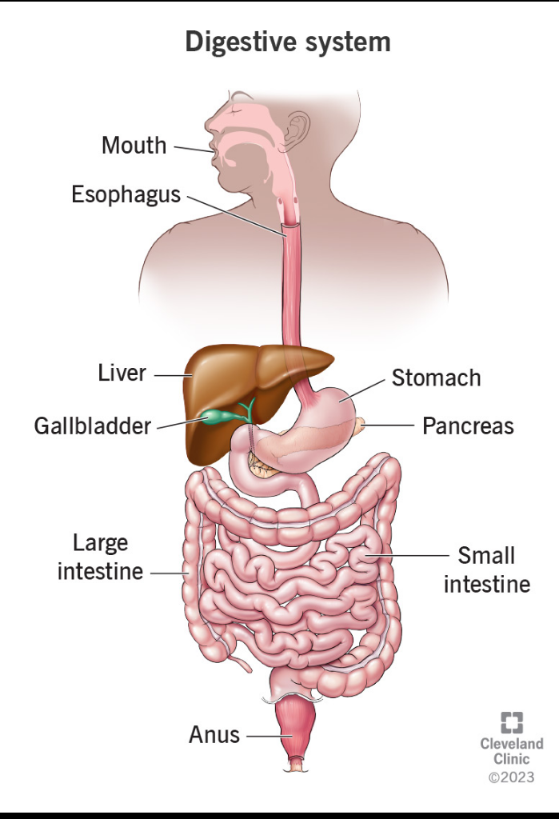

**Instructions**:

*Fill in the blanks with the correct words from the word bank provided*.

**Word Bank**:

1. Esophagus

2. Stomach

3. Small intestine

4. Large intestine

5. Saliva

6. Pancreas

7. Liver

8. Gallbladder

9. Digestion

10. Nutrients

11. Enzymes

12. Rectum

13. Mouth

14. Anus

15. Bile

**Questions**:

1. The process of breaking down food into smaller pieces is called __________.

2. Food enters the digestive system through the __________.

3. The __________ is a muscular tube that connects the throat to the stomach.

4. In the stomach, food is mixed with digestive juices, including __________, which helps break down food.

5. The __________ is where most of the digestion and absorption of nutrients occurs.

6. The __________ produces bile, which helps digest fats.

7. The __________ stores bile until it is needed for digestion.

8. After the small intestine, the remaining waste moves into the __________.

9. The __________ is responsible for absorbing water and forming waste.

10. The final part of the digestive system is the __________, which eliminates waste from the body.

11. __________ are special proteins that speed up the digestion process.

12. The __________ helps regulate blood sugar levels and produces digestive enzymes.

13. __________ is a fluid produced in the mouth that begins the digestion of food.

14. The liver also helps filter toxins from the blood and stores important __________.

15. The __________ helps transport food from the mouth to the stomach.

.